Terrestrial Field Crew Summer Handbook
Arctic LTER VII

2025

Adapted from portions of prior protocols created by Ruby An, Jim Laundre & Nicole Williamson
Last edited on: 06/04/2025
Last edited by: Savannah Kjaer, Amelia Harris
Table of Contents

The Big Picture

Helpful links to get you started
Passwords
- Contact Information for 2025
- Approximate Field season Timeline
- Daily log
- Weekly meeting
- Shipping Information
- Experiments & Plot Maps for 2023 Fieldwork
- Spring Setup Instructions
Warm Storage Request
- Dataset Measurement & Processing Protocols
Thaw depth
Spectral Reflectance
Plant Abundance: Relative percent cover
Requesting EDC Support
- Data Management

Priorities during ‘slow’ times

End of Season Instructions

Appendix 1. Printing on Rite in the Rain paper
Appendix 2. Where to measure Thaw Depth measurements in the plots of MAT06 Experiment & the CT plots of each of the 89 series of Experiments
Appendix 3. The very basics of operating the UniSpec.
Appendix 4. Plot measurement key for UniSpec measurements in the plots of the MAT06 Experiment & the CT plots of the 89 series of Experiments.
Appendix 5. Instructions for calibrating Percent Cover estimates among observers.
Appendix 6. Answers to the Relative Percent Cover practice question in Appendix #5.
Appendix 7. Plot measurement maps for Percent Cover measurements in MAT06 Experiment.

- The Big Picture

“The Arctic is rapidly warming. Some responses to this warming involve acceleration of processes common to other ecosystems around the world (e.g., shifts in plant species), whereas others are unique to the Arctic but with global consequences for society (e.g., carbon loss from permafrost thaw). The objectives of the Arctic Long-Term Ecological Research (ARC-LTER) project for 2023-2029 are to determine how and how fast trends in climate change and especially climate variability are changing arctic ecosystem structure and function. To understand these changes we will extend our use of the concepts of biogeochemical and community “openness” and “connectivity,” developed during our previous award, to understand the responses of arctic terrestrial and freshwater ecosystems. These objectives will be met through continued long-term monitoring of changes in undisturbed and disturbed ecosystems along the terrestrial to aquatic continuum in the vicinity of Toolik Lake, Alaska. In addition, we will measure the recovery of these ecosystems from natural or imposed disturbances, maintain existing long-term experiments, and initiate new experimental manipulations and observational studies to achieve the objectives. Based on the data generated, carbon and nutrient budgets and measures of species composition and abundance will be compiled for major components of the arctic landscape. Through a combination of data analysis and modeling we will assess how climate change and climate variability will affect biogeochemistry and community dynamics of ecosystems, and determine how ecosystem responses will propagate across the landscape.”

-Overview, ARC-LTER VII Proposal

Helpful links to get you started

Welcome to the Arctic Long Term Ecological Research (ARC LTER) team! The LTER Network was established in the 1980’s by the National Science Foundation (NSF) to support long-term ecological research all over the United States. You can learn more about the ARC LTER’s goals and access our long-term datasets HERE.
Our research site is located in the foothills of the Brooks Range, North Slope of Alaska. We are based out of the University of Alaska’s Toolik Field Station (TFS). On the TFS webpage, you will find links to pretty much everything you need/might want to know, such as (but certainly not limited to):
Life at Toolik - Nearly everything you need to know about life at Toolik can be found here
Map of Toolik Field Station - Includes an interactive aerial view of the station
Environmental Data Center (EDC) - The EDC maintains several different long-term data sets including both biotic (bird counts, plant phenology, and NDVI), and abiotic (weather, meteorological, snow depth, ice thickness, atmospheric, time-lapse imagery, and more). They also have plant and several animal guides. For example, there are these:

- Toolik’s EDC plant guide
- Plant ID Quizlet
- Tricky plant ID help
Passwords
- Terrestrial RA laptop
  - Username: TerrestrialLTER
  - Password: 2845dalton
- Google account
  - TerrestrialarcticLTER
  - Password: MAT89_MAT06

Contact Information for 2025

PIs & Senior Personnel
Name | Email | Phone #  (work, w; mobile, m) | Unavailable (U)/  Limited availability (L)
Kevin Griffin | griff@ldeo.columbia.edu | (845) 365-8371 (w) (212)854-7566 (w2) (845)422-1364 (m)
Natalie Boelman | nboelman@ldeo.columbia.edu | (415)793-3479 (m) | June 20-July 2 (U)  July 3-July 12 (L via text)  Aug 3-Aug 12 (L via text)
Duncan Menge | dm2972@columbia.edu | (609)571-7773 (m)
James Laundre | jlaundre@mbl.edu | (774)208-4120(m) | Jul17-21(L)
Laura Gough | lgough@towson.edu | (214)680-1627

Graduate Students, Undergraduate Students & Research Assistants
Name | Email | Phone # | Advisor(s)/Responsible PI
Savannah Kjaer  (Senior RA) | sjk2257@columbia.edu | (952)220-3006 | Griffin, Menge, Boelman, Laundre
Amelia Harris | ahh2155@barnard.edu | 650-922-2635 | Griffin, Menge, Boelman, Laundre

- Approximate Field Season Timeline

- Daily log
While in camp, we ask you to keep a daily log of what was done by the crew each day, and also make notes on important or concerning things you may have noticed at the experiment sites or elsewhere. When in camp, you are the eyes and ears of the terrestrial portion of the Arctic LTER project. The daily log will serve as a way to keep those of us who are not in camp – especially the PIs – in the know, ready to guide you as things come up, and assured that things are going smoothly and are on track. Please be sure to take a few minutes every evening to keep the log up to date.

Savannah has already begun a 2025 Daily Log file in Box, which can be accessed here, in the Toolik2025 folder:
https://app.box.com/notes/1883212242993
Additionally past years’ daily logs and calendars can be found here for reference.

- Weekly meeting

Mondays @ 9 am AK time (1 pm Eastern)

- Starting Monday June 9th through to the end of summer, we will be holding a weekly Zoom meeting to connect those of us who are in the field with those of us who aren’t.

- These meetings will serve as a way for:

1. the Undergraduate/Graduate Students and Research Assistants to communicate and seek guidance with respect to task prioritization, needs and troubleshooting of any kind.

2. the PIs/Advisors/Mentors to stay updated on the terrestrial crew’s activities.

- Zoom meeting room: Join our Cloud HD Video Meetingcolumbiauniversity.zoom.us
(https://columbiauniversity.zoom.us/j/96088799164?pwd=RTVaSi9PVW5vUjM3MEJ4NW1LUWtqQT09)

Shipping Information

Northbound: Lower 48 à Toolik

Address: Name (Lab #)
2120 Koyukuk Drive, Room 138
IAB Toolik 757005
Fairbanks, AK 99775-7005

Ship by date: Mid-May (to have things arrive at Toolik by early June)

Notes: More details about shipping to Toolik can be found in the dropdown menus at https://www.uaf.edu/toolik/handbook/shipping-transportation.php

Southbound: Toolik à Lower 48

Please follow all of the instructions provided within the appropriate in the dropdown menus at https://www.uaf.edu/toolik/handbook/shipping-transportation.php

To ship packages from Toolik to Fairbanks you will need to complete a support request through myToolik. You will need to provide the date your packages will be shipped (you can find the days trucks are running south on the board in the DH), a description of items (including measurements), and hazmat or special instructions. Packages should already be secured, labelled and paid for when sent south.

Once in Fairbanks the logistics office will ship your packages, typically the next day. Temperature controlled or hazmat items will be held until the beginning of the week to avoid weekend shipping delays.

VIII. Experiments & Plot Maps for 2025 Fieldwork

Locations. For the 2025 field season, there is one main experiment that you will work in for sure, although other things may come up via the Arctic (e.g. see Priorities during ‘slow’ times). There are four other experiments that were monitored in past years, but annual work on these experiments concluded in 2023. Below is a list of these experiments and their approximate locations are shown on the satellite image.

2025 LTER Active Experiments:
MAT06 (all Blocks @ 1 site)
Retired LTER Experiments:
MAT89 (all Blocks @ 1 site)
WSG89 (Blocks 2&3 @ ‘WSG89-Outlet’ site, Block 1 @ ‘WSG89-Inlet’ site)
SHB89 (Block 1 @ ‘Shrub Block 1’ site, Block 2 @ ‘Shrub Block 2’ site)
DHT89 (all Blocks @ 1 site)

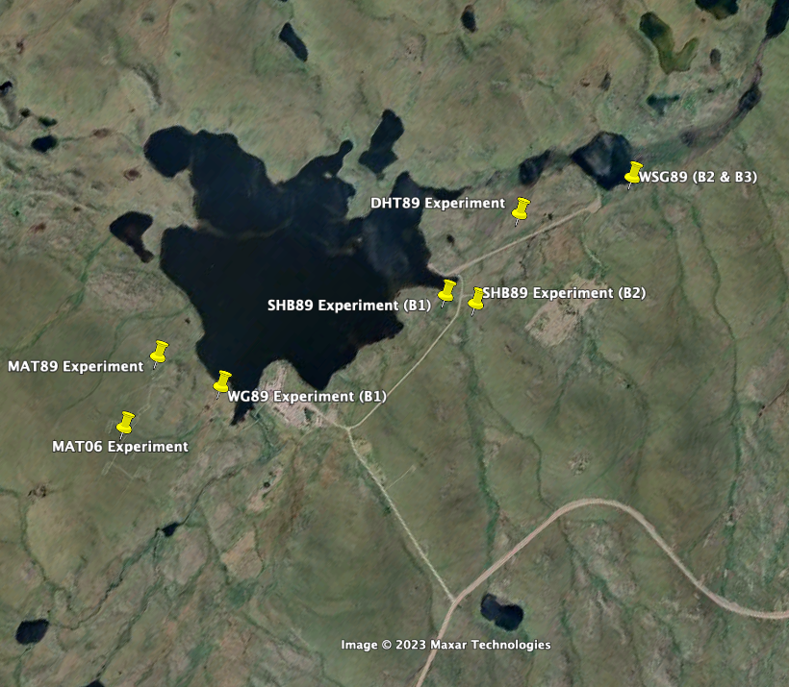
Plot Maps. Below you will find maps showing exactly how each one of the current and former LTER Measurement Experiment Sites are laid out. Note that for each experiment, there is more than one ‘Block’ (some experiments only have 2 blocks, while others have 3 or more) and each one of those Blocks is comprised of a suite of experimental treatment (or Control, CT) ‘Plots’. The purpose of having more than one Block is to provide replication of each of the experimental treatments. The Blocks that make up each experiment are typically located at the same field site, but note that there are a couple of experiments for which the Blocks are located at separate field sites (i.e. WSG89 and SHB89).

Maps of all sites can be found in the ‘Site_maps/maps’ folder in Box.

MAT06 (all Blocks @ 1 site)
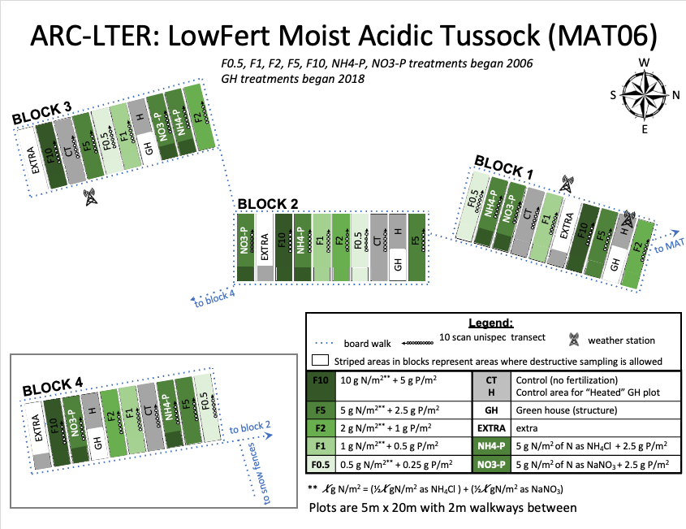

MAT89 (all Blocks @ 1 site)
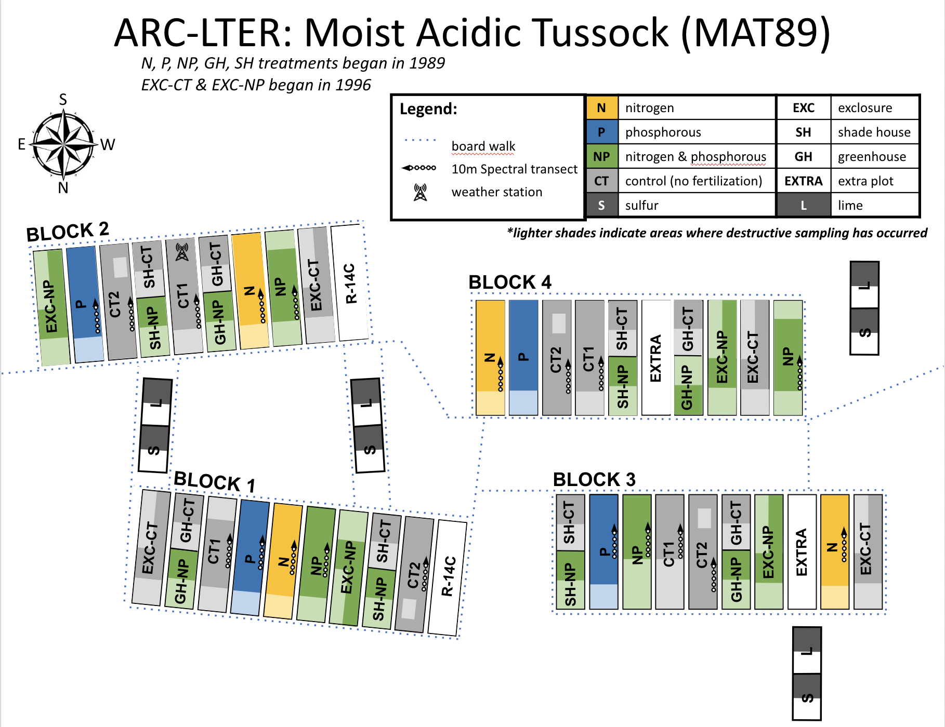

WSG89 (Blocks 2&3 @ ‘WSG89-Outlet’ site, Block 1 @ ‘WSG89-Inlet’ site)
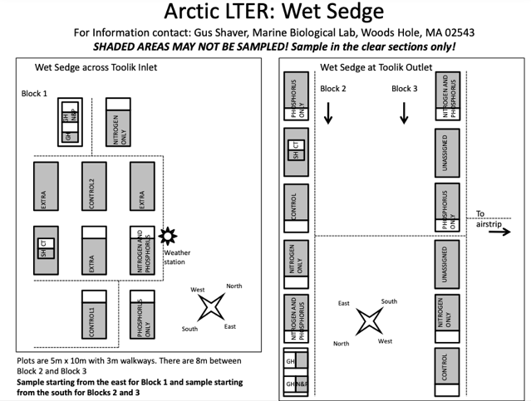

SHB89 (Block 1 @ ‘Shrub Block 1’ site, Block 2 @ ‘Shrub Block 2’ site)
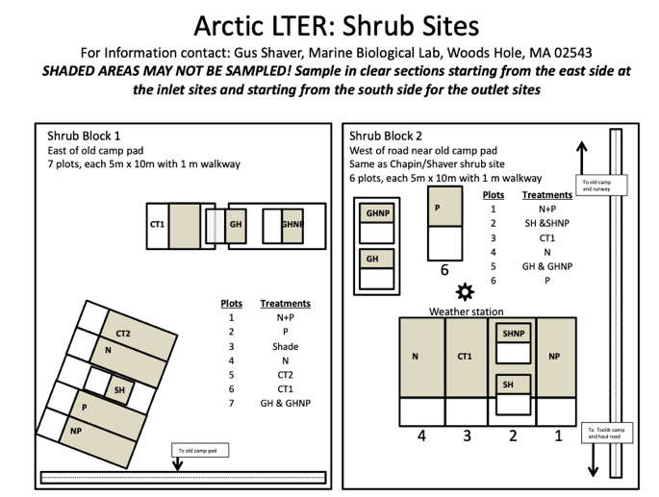

DHT89 (all Blocks @ 1 site)
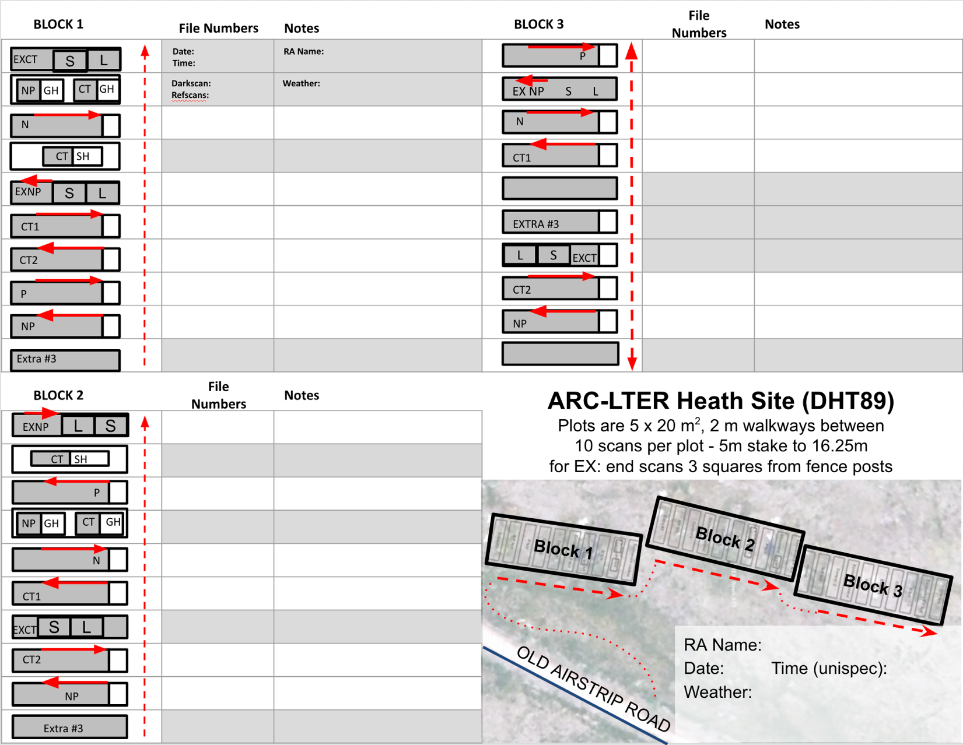

IX. Spring Setup Instructions

Introduction. Every spring we have to ‘setup’ ongoing experiments. This setup involves three main field tasks:

Erecting greenhouses

Applying fertilizer

Servicing (and possibly moving) environmental monitoring stations

Who, When, Where & How

Erecting the greenhouses in the MAT06 Experiment (TOP PRIORITY, please do this first)
Two, ideally three people for one day, as soon as plots are snow-free.
Procedure: \Manuals_and_Procedures\Greenhouses\‘Greenhouse setup&takedown’

Fertilizing the MAT06 Experiment
Two people for one day in the field, as soon as plots are snow-free.
It is essential to review the amount of fertilizer available in the tote on the hill (large white container by MAT89 plots on the top of the hill, ratch strapped shut) before beginning this task. If there is not enough fertilizer already up the hill more will need to be located in either the conex (large shipping container next to lab), doghouse (small woodshed behind the conex), or the Cold Storage building (note for 2024- fert in conex, shared with Rocha). Additional fertilizer bags are 50 lbs so are carried up in the frame packs (in the drying oven room in Lab 2).
Procedure: \Manuals_and_Procedures\Fertilizer_Instructions\‘Arctic LTER fertilization protocol.docx’

Environmental monitoring stations located in LTER Experiments
Approxiamtely one person one day, this can be done as visits to these sites are made. This is the least time sensistive setup task, but should still be completed as soon as possible after fertilizing and GH setup.

Replacing desiccant: Briefly, every datalogger box (large white boxes on poles equipped with various other measuring instruments, including a solar panel) contains a few desiccant packs to fight moisture over the winter. At the start of the season, we want to grab these packs, dry them in a drying oven for ~48 hours, then return them. Some of the boxes, especially the smaller ones, have a wood panel screwed over the dataloggers, so you’ll want to bring a small screwdriver. It doesn’t matter which packs go in which datalogger, though some of the smaller dataloggers can only fit smaller packs, so take note of these. Repeat this at the end of the season before leaving for the winter.

Check all the dataloggers are working and reporting. Check the weather station data on the LTER website and see if any sensors are not reporting/falsely reporting, with MAT06 sensors taking top priority. There should be sensors for
    - air: temp; rel. humidity
    - soil: temp (@ surface; 10 cm; 20 cm) & moisture
    - battery
Air temperature should approximately match weather reports, soil temperature will likely be below freezing. Other sensors such as relative humidity will be more difficult to judge, look for steep drops or large variations compared to months prior. Particularly with the soil sensors, permafrost thaw/freeze can dislodge the sensors or push them higher. If these values seem suspect, you may need to find and re-insert a probe. If the battery is low/dead or another sensor is not reporting this will require checking the connection to either the solar panel/battery or sensor to the datalogger panel. See more information about dataloggers here.
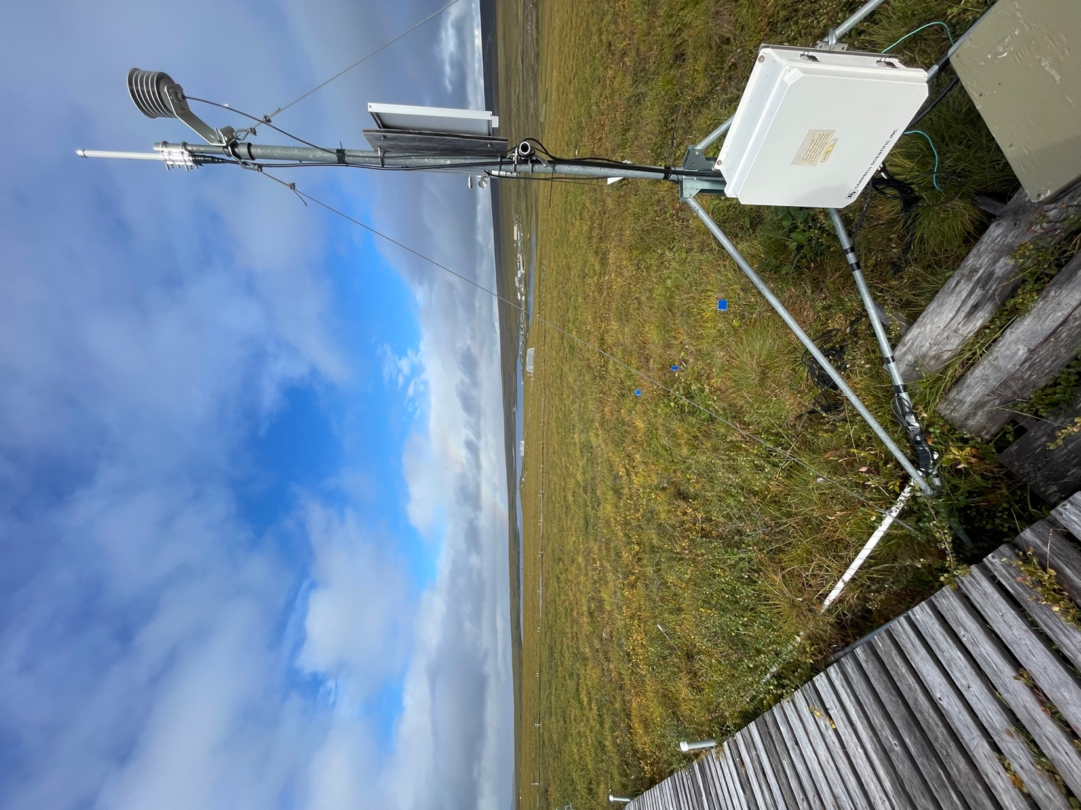
Weather Station with Datalogger box

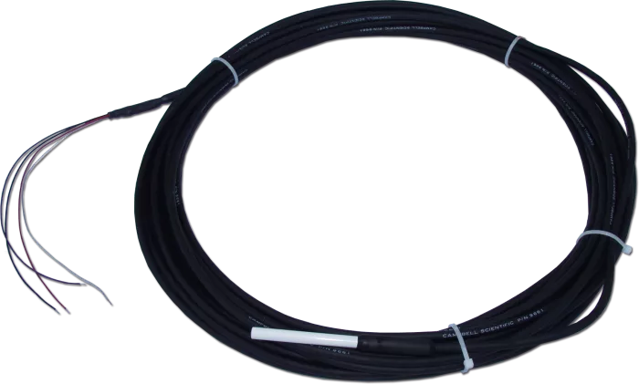
Soil temp sensor: https://www.campbellsci.com/107

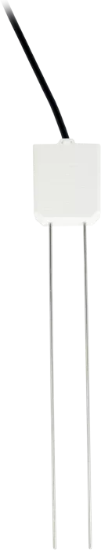
Soil moisture probe: https://www.campbellsci.com/cs616-reflectometer

Temporary boardwalks
- This should probably start as a whole team discussion during one of the early weekly calls to determine possible need based on nature and frequency of sampling planned in LTER Experiments.

Back in the lab

Warm Storage Requests
Items that cannot be frozen are stored in Warm Storage over the winter, as the labs are not heated during off-season. You must make a request to Toolik staff through your myToolik account to store or retrieve these items.
      - In myToolik, under the ‘Support’ tab, click ‘Request Support’. On the Support Request System page Under ‘Operations’ you’ll select ‘Warm Storage’.
      - Your PI is ‘Griffin, Kevin’. Project is ‘Arctic LTER’.
Unispec:
      - 2 briefcase style boxes
      - 7”x16”x10”
      - Comments: labeled ‘GRIFFIN LTER LAB2 UNISPEC’ one Unispec-DC, one Unispec-SC
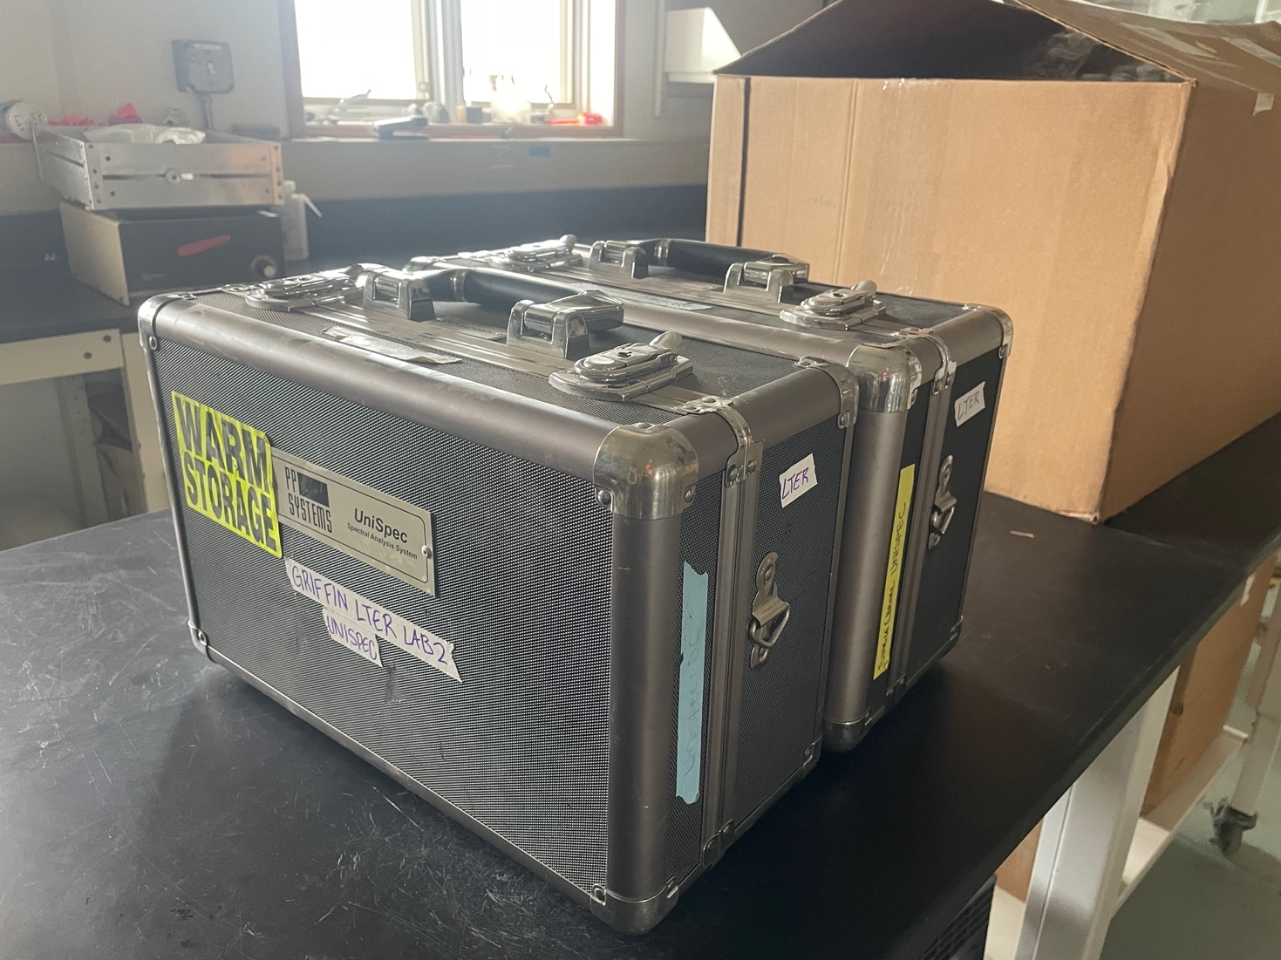
Rapidscanner:
      - 1 box
      - 12x5x10”
      - Black box with handle and red bungee cord wrapped around

At the end of the season, this equipment needs to be stored in warm storage again. Another request must be submitted, then a Toolik staffer will come retrieve your equipment.

X. Dataset Measurement & Processing Protocols

Thaw depth
Who. Two people are best for this job, where one is the observer using the probe and the other is recording the depth of thaw value.
When & Where.

Weekly: Starting as soon as plots are snow-free (~early/mid-June) through mid-August

MAT06 Experiment: All treatments & blocks

Note: Based on previous sub-weekly(!) measurements in the MAT06 Experiment made by Dr. Jennie McLaren a few years ago, the biggest differences in thaw depth (and soil temperatures) between treatments seems to occur at the end of June/early July. This suggests that this particular time period of the growing season could be critical to understanding how greater nutrient availability (i.e. release from nutrient limitation) affects tundra ecological form and function both belowground and aboveground. Please be extra careful not to miss making weekly measurements during this time.

- Just once: Mid-August
MNT97 Experiment: CT only, all blocks
WSG89 Experiment: CT only, all blocks
SHB89 Experiment: CT only, all blocks

  - Note: You will not be making thaw depth measurements of DHT89 Experiment because there is barely any soil/PF to probe into, just rock

Procedure: \Manuals_and_Procedures\Thaw Depth\’Thaw depth protocol’

Spectral Reflectance
Introduction. Spectral reflectance of the canopy provides a wealth of information on the status of the vegetation, from phenology, greenness to productivity and beyond. We make measurements (of spectral irradiance from the canopy, which are later converted to spectral reflectance of the canopy) using a UniSpec DC spectroradiometer. The protocol may take a while to master, but is set-up to optimize efficiency and before long will become second nature. Once you know what you are doing, they are pretty quick to make. And, you should feel inspired by the fact that you are adding to over a decade of spectral reflectance data!
Important: Before using the UniSpec please take time to carefully read through the following resources that will help you understand the instrument and therefore help to ensure that you are collecting high quality data (in order of most basic to detailed):
- Appendix #3 of this handbook provides basic operating information.

- Unispec-DC Protocol in (Box\ARC LTER 7 (Terrestrial)\Manuals_and_Procedures\Unispec\’UnispecDC_Protocol_2023.docx’)

- A People’s Guide to UniSpec-DC Measurement and Data Prep by Jeremy K. Cave (…\Manuals_and_Procedures\Unispec\’UnispecDC_Manual-Peoples_guide_2018.docx’)

- The UniSpec-DC manual (in binder in Lab 2 and also in (…\Manuals_and_Procedures\Unispec\Unispec-DC Operator Binder Manual.pdf)
- Click HERE to download a video further explaining what ‘integration time’ is so that you understand what you’re actually trying to do when you have to set it in the field!

Who. 1 person (although a 2nd person can be nice for file number recording and note taking).
When & Where.
Weekly: Starting as soon as plots are snow-free (~mid-June) through mid-August

MAT06 Experiment: All treatments & blocks

However, timing these measurements is not as straightforward as just planning to go out there every Monday or Wednesday, for example. Instead, it is critical that you follow these 3 basic guidelines in deciding when exactly you are going to be able to make useful measurements:
- Minimize shadows by measuring close to Solar Noon (14:00). Try not to start before 10:00/11:00 or go past 16:00. If it is slightly overcast with more diffuse light, shadows are less of a problem. Try to measure sites at similar times of day within throughout the summer.
- What is “good enough” weather to spec? Since we’re using the Dual Channel UniSpec, varying light levels are less important for measurements, as each scan takes into account upward and downward light. Highly variable cloud cover does makes it difficult as the raw spectra will change a lot and can easily max out (above 65,000 A/D). Be sure there is enough light to make good readings (max of CHANNEL A around 50,000 A/D). Balance getting any data with getting good data and always make note weather conditions and other factors!
- Avoid taking measurements of wet vegetation. Water droplets on leaves can artificially lower reflectance in some wavelengths. You may need to wait for vegetation to dry.
The bottom line is that although weekly measurements are what you should aim for (i.e. ideal), there may be a week (or two) when you can’t measure at all due to the above constraints. At the very least, please be sure to capture green-up (early to mid-June), peak greenness (early to mid-July), and senescence (mid-August).
Just once: Mid-July
MAT89 Experiment: CT only, all blocks
WSG89 Experiment: CT only, all blocks
DHT89 Experiment: CT only, all blocks
SHB89 Experiment: CT only, all blocks ***measured with RapidScan

Before going into the field.
Prepping the UniSpec:
- Charge the UniSpec the DAY BEFORE you intend to head out, and during lunch if doing more than 3 sites per day.
- Set the Instrument settings. You can do the following steps in the field. However, it’s easier to do them in the lab before you leave for the field.
- Turn on device (give it about 10 minutes to warm up)
- Access the set up menu by pressing “1”
  - In the “File Prefix” box, enter the site name abbreviation (Ex: mat06_ )
  - Change “Start number”to 0
  - Make sure “Scan button does one scan” is selected, but check that the “autointegration time” is set to 20000sec (to prevent automatic scans)
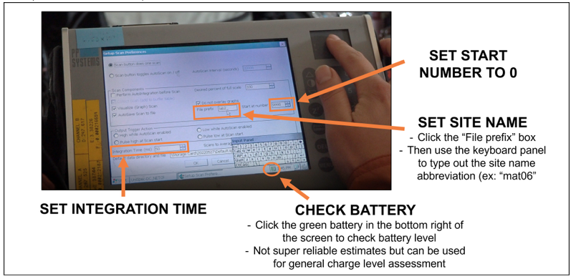
- Set the save folder
- Click the “Browse” button next to the “Default data directory and file” box
- Then click “Storage Card”
- Then create a folder with today’s date (YYYY.MM.DD)
  - Files will then automatically save into this folder with the site prefix and then the file number, counting up (Ex: mat06_00001.spu)
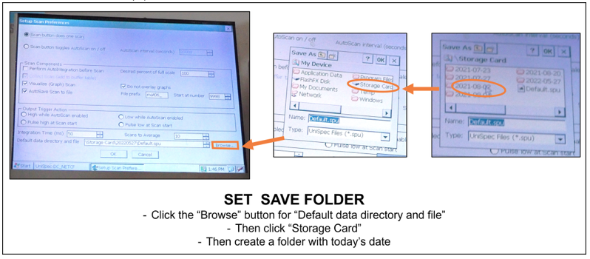
- Turn off the device
- Pack the UniSpec in the bottom of a field backpack
  - You can find backpacks on the rack in the entryway to the lab with the drying ovens in Lab 2.
  - If you happen to be going across the lake make sure you put the UniSpec and other equipment into a dry bag!
Field supplies to round up:
- UniSpec DC with PCMIA card and adapter inserted
- Monopod - 2 m metal cross attached perpendicularly to one another & typically located by the rack next to the flammable cabinet in Lab 2
- Reference disc holder & orange clamp (make sure the white reference holder/clip is attached to the monopod. You can either leave this on while you carry it to the field, or you can take it off and store it in the backpack)
- White reference disc in bag with sandpaper
- 2 x foreoptic cables in protective box. Cable A connecting to the cosine receptor (small black rectangular prism). Cable B has a long metal tube to adjust the FOV.
- Clipboard
- Pencils
- Plot measurement maps so that you know where to make the measurements in each plot. You can find them in Appendix 4 and also here in Box (Box\ARC LTER 7 (Terrestrial)\Unispec_tools\keys)
- Copy of the below UniSpec instructions
- Datasheet/Key/Field notebook (Rite in the Rain) to record date, weather, #'s for dark scan, reference scan, file numbers for each plot you measure.
Important:
To print on Rite in the Rain paper you must use a laser printer for this or the ink won’t dry. *Please refer to Appendix 1 for instructions on how to do this.*
DO NOT USE DEET near the equipment, and be mindful of it being on your hands/what you touch. DEET will damage glass and plastic and could ruin the sensors)
What to do in the field.
- When you arrive at your site, the first thing you should do it take out the UniSpec and turn it on.
- Wait 10 min for machine to warm up. While waiting:
  - Attach the upward and downward facing fore optics to the monopod (DO NOT ATTACH TO UNISPEC YET)
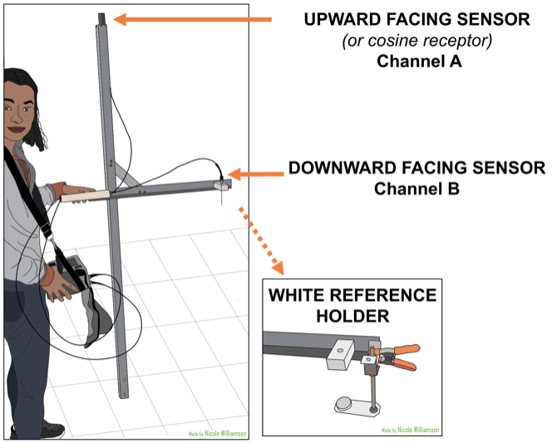
TIP: Hold both cables in one hand while supporting the monopod in its upright position. Carefully attach upward facing sensor first by sliding the wire into the slot on the tip of the monopod so that the rectangular sensor sits on top. Then attach the downward facing sensor to the arm of the monopod by sliding the needle-like end into the hole in the plastic white rectangle so that that the needle-like end is facing down towards the ground. Finally, while being careful not to twist or bend the cables, or let the ends touch the ground, feed the ends of both cables through the PVC tube and attach.
  - Clip white reference holder onto monopod
  - Weather / Conditions– write in notebook. Clouds, haziness, sun angle, moisture on leaves all affect scans.

- Proudly dawn the UniSpec by putting the strap over your head and around your neck. Adjust straps so that the device rests in a comfortable position. If you didn’t set scan preferences before heading into the field, do so now per the instructions in the previous section.
  - Press “1”
  - Change “Scans to Average” to 10
  - Set integration time according to weather:
    - 40-50 ms – sunny
    - 70-100 ms – mildly cloudy
    - 160-200 ms – thick clouds
When set, click “OK” then it will say “rebooting detector channels” Once that message is gone, you should be ready to take a scan
- Attach foreoptics cables to UniSpec. Cables and ports are color coordinated
  - orange = Channel A/upward facing sensor
  - green = Channel B/downward facing sensor
- Perform throwaway scan: Initializes channels after the instrument has been turned off and helps you determine if your integration time is appropriate.
  - Press “2” when ready to take the scan.
  - You want Channel A to peak somewhere around 50,000 A/D. If it is higher than that, shorten the integration time. If it is lower, increase the integration time. However, it is important to not max out at 65000 A/D. Any reflectance higher than this will not be recorded and these scans will be unusable.
  - Adjust the integration time as needed and repeat throwaway scans until the desired peak has been reached. Anywhere from 40,000-55,000 A/D is fine, as the reflectance will vary with cloud cover. Keep an eye on the scans as you measure, particularly if there is a change in light, to ensure you stay near this range, and do not exceed 65,000. Record throwaway scans file numbers.
- Perform a dark scan: Detach the cables and fold the cover of the case over and press it into the ports for the two cables on the back of the device so that no light can get in. Press “3” when ready to take scan.
- Check the dark scan readings:
  - Values btw 100-300 A/D are optimal. Relatively uniform noise across all wavelengths.
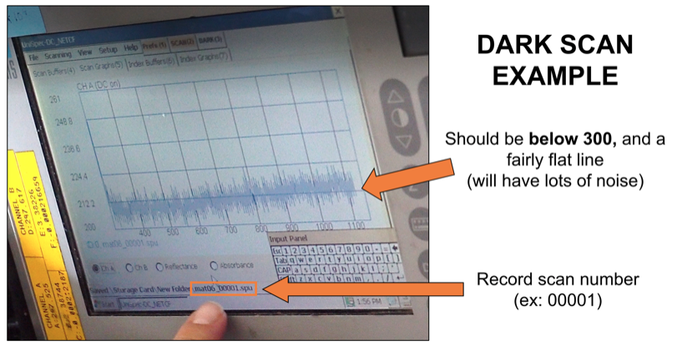
  - Dark scan measures instrument noise. Important to redo if you change integration time by more than 40ms or temperature changes.
  - RECORD DARK SCAN NUMBER. You can see the scan number displayed along the bottom of the screen

- Perform the WHITE reference scan
  - White reference disc should theoretically reflect 100% of the light coming in. This only happens if its clean, and free from scratches. DO NOT touch the surface of the disc, only touch the sides. Oil from your hands can distort light refection. Examine disc before use to make sure it is clean, sandpaper surface if necessary.
  - Place the disk in the white reference holder (attach if need be) beneath the downward facing sensor– make sure it is close but no shadow on disc and it is at the same angle to sun as the upward facing sensor. To check if disk is under the sensor by removing the sensor from its holder and looking down through the hole to make sure you see the white disk.
  - Go to the plot you are going to take measurements in and line the UniSpec up in the same location and direction as you will be taking your real measurements. Do your best to also make sure the monopod is level (use the level on the arm of the monopod).
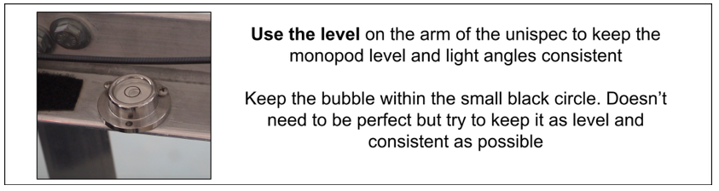
  - Take a measurement by pressing “2”
    - CHECK THE REFLECTANCE VALUES - for the white reference you want channel A and B to look similar and have similar magnitudes
    - Channel A max should be around 50,000 A/D. Channel B should be similar but tends to be a bit lower
  - Take 4 more scans in the same spot (total of 5) to account for small changes in light and cloud cover.
  - RECORD WHITE REFERENCE FILE NUMBERS
  - Remove the white reference disk and holder and store in backpack
- Prep for real measurements:
  - Press “1”
  - Change “Scans to Average” to 1
- Make real measurements
  - Align the monopod on the edge of the plot. Level with the bubble. Press 2.
  - Check to make sure CHANNEL A and CHANNEL B do not max out at 65000 A/D. If so, redo measurements with a shorter integration time.
  - Check that upward facing CHANNEL A has higher raw signal values than downward facing CHANNEL B (the only exception is the REF scan). Ideally, the raw signal spectra should peak at around 50,000 A/D for CHANNEL A.
  - Take 5 measurements along 5m transects as marked on plot maps and with silver tags on boardwalk.
  - RECORD WHICH BLOCK AND PLOT CORRESPONDS TO EACH SET OF 5 FILES before moving onto the next treatment
NOTE: If cloud/lighting conditions change a lot while you are taking measurements, take another set of white reference scans at the end.
- When you are done, turn the device off. Disconnect the cables, and repack everything for transport.

Tips & troubleshooting in the field
- Made a mistake? If you would like to redo some of your scans, you can press 1, and then set the “Start at number” back to whatever number you want to restart at. THIS WILL ERASE all measurements you took after that scan number so make sure you really want to do that
- Difficulty finding cursor - Adjust brightness up and down (arrow buttons to the middle-right of display) so that white shows up better. When you press 1 for “Scan Preferences”, the cursor always appears over the “OK” button.
- Bad Spectra - If anything looks weird, go back and consult A People’s Guide to UniSpec-DC Measurement and Data Prep for examples of spectra and other common problems.
- Hazards! When at shrub sites or near greenhouses or other structures, be mindful of where the wires are so they don’t get snagged on anything

Back in the Lab: To do (almost) immediately! As detailed immediately below, and also following the general guidelines found in the Data Management section (lower down in the Handbook), please immediately take a photograph of your datasheet(s) and digitally enter, quality check, organize and backup your data.
It is critical to make time to transfer data files from the PCIMA card to the ‘Toolik2023’ folder in Box and run the R script (unispec_quality_check.R, found here: INSERT LOCATION LINK please) to quality check THE SAME DAY you take measurements. This is because you may think you have perfect memory now, but you will forget! Record electronically which file numbers belong to which plots, reference, or dark scans in the UniSpec File Key (‘2023_unispec_key.csv’, which can be found here: INSERT LOCATION LINK) and delete any unnecessary files. Here’s how…
Transferring data from UniSpec to Box cloud storage:
- Remove PCIMA card from UniSpec DC
  - Eject the card by pressing the small black button next to the memory card on the back of the device.
  - The memory card is contained within an adapter, carefully pull the card out of the adapter
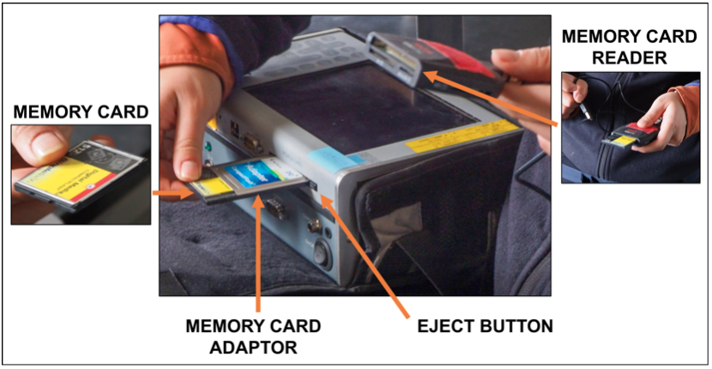
- Insert card into reader with USB connection to computer
  - Be careful to align the PCIMA card properly to avoid bending any of the metal prongs on the connector!!
  - If this occurs, you can straighten with pliers & reinsert card to realign.
- Transfer data folders to computer. Move folders named with (YYYY-MM-DD) containing SITE_XXXXX.spu files to appropriate locations in Box (see Data Management section below for details associated with storing and organizing these folders in Box).
- Fill out UniSpec File Key (‘2023_unispec_key.csv’, which can be found here: INSERT LOCATION LINK) by adding notes & file numbers to this Excel spreadsheet.

Proofing the data you collected today:
- use the RShiny app created by Jim Laundre to check the quality of the data.
- Open the Unispec Shiny App.
- Click “Browse” under “Upload .spu files” and select all the .spu files within today’s date folder.
- Click “Browse” under “Upload Field Key Excel files” and select the field key you created for today.
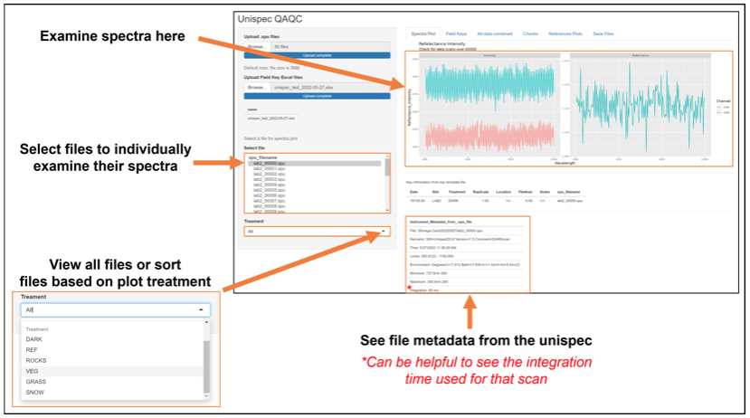

Tips & troubleshooting quality check
Missing/mislabeled files. Human error is real. You hopefully kept track of file number / plot correspondence in the field; however, if you get back to lab and something doesn’t line up, there are several tricks you can use.
- Look at measurement times. Using the “unispec_quality_check.R” file, look at the times you took each measurement. One line of code will give you a dataframe with the difference in time between each measurement. Usually, you can tell which 5 measurements you took at a single plot (small difference in times) and when you moved between plots (longer times) or blocks (even longer) depending on how far you have to walk.
- Check spectra. You may have simply be off by one due to mislabeled reference or dark scans. Check the spectra of any subset of file numbers to make sure

Plant Abundance: Relative percent cover

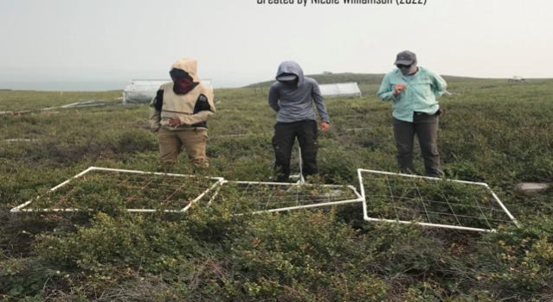
Introduction. Plant abundance is estimated as relative percent cover every year across multiple plant community types. We do this to monitor changes in plant communities over time in response to experimental manipulations, such as nutrient addition and warming with greenhouses.

Who. Two to three people per frame, one of those people recording while the others observe. With four people one can record as three people look on two adjacent frames.

Requesting EDC Support
Note that EDC assistance can be requested to ensure data is collected within the ‘peak green’ window, approximately 2 weeks. Please plan ahead as follows: Please make a Support Request to the TFS Environmental Data Center (EDC) asking if they would be able and willing to make these critical measurements for the LTER. Instructions on how to do this are pasted below but can also be found here: https://www.uaf.edu/toolik/edc/about/services.php

Field Work Assistance & Remote Access
TFS offers year-round support through field assistance and remote access to projects based out of TFS. Requests for field assistance and remote access need to be made in advanced using the Support Request System - Remote Access form.
- Field Work Assistance: Assistance to researchers at the field station.
- Remote Access: Assistance to researchers in lieu of their presence at the field station.
Remote access can be used to extend seasonal sampling into the shoulder seasons, brief weekly sampling over a field season, short intensive campaign, data downloads and so much more. Please contact Amanda Young (ayoung55@alaska.edu) for more information about our support services.

When. Plant cover should be estimated around “peak green” (when the tundra’s vegetation cover is at its lushest). This typically occurs in mid- July through late July.
Where. MAT06 Experiment (all 4 Blocks, all treatments)
Before going into the field: Prepping & collecting the following supplies.
- 1 m² quadrats (2 or more) which are 1x1 m gridded frames constructed out of PVC and string. Each quadrat is divided into 25 (20x20 cm) sub-quadrats. The quadrats are typically located under Lab 2. They look like this:
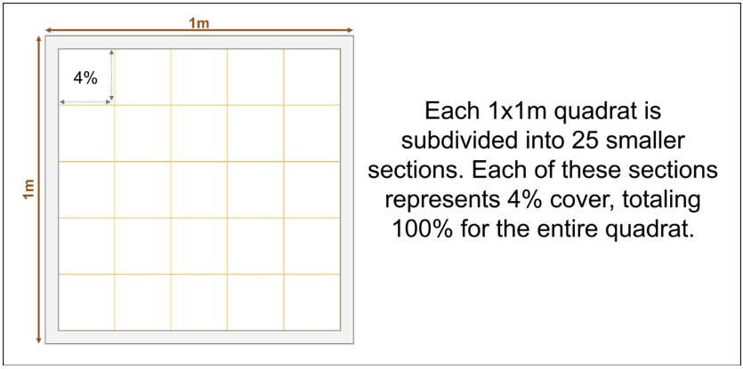

- Data sheets & Species lists
  - Download datasheet and species list (both are included in Percent_Cover_DataSheet_2025.xls, which you can find here
  - Print datasheets and species lists on Rite in the Rain paper. To print on Rite in the Rain paper you must use a laser printer for this or the ink won’t dry. **Please refer to Appendix 1 for instructions on how to do this.**
- Clipboard
- Pencils
- Note book
- Camera/Cellphone - used to take photos of any unknown species you encounter so you can look it up later

What to do in the field.

- Before you begin recording data you need to “calibrate” your estimates with those of the other observers in order to make sure you are all getting around the same numbers (within 5-10%). Calibration should be done each time you do cover, any time you begin a different plant community (ex: switching from MAT to DHT) and anytime you add a new person. Please refer to Appendix 5 (and Appendix 6) for instructions on how to “calibrate”.
- There is an 8 m long transect in each plot where we measure plant cover each year (see Appendix 7 for map showing where these measurements are made in each plot)
  - 1 m² quadrats are placed side by side along this transect. We typically use 2-3 quadrats at a time and work in teams of 3-4 people (with 2-3 observers and/or 1-2 recorders)
- To estimate plant cover do your best to get a birds-eye view of the quadrat
- One 20x20 cm string square represents about 4% of the area of the quadrat
- Using this as a guide, you will estimate the area (in percent) of the plot a given species makes up. Typically, it is easiest to go square by square and add up as you go
  - TIP - Sometimes you may want to intentionally overestimate the cover of a species in one square if there are several squares with less than <1%. (Example: I will say that a square that looks to have 2% cover of Betula as instead having 3% if the next few squares after it each have a very small amount. In other words, I’m looking and estimating ahead a little.)
- Note that the percent cover estimates you make will be relativized so it’s okay if the quadrat totals do not total to 100%!
- Give the practice question in Appendix #5 a try. The answers are in Appendix #6.

Back in the Lab. As detailed in the Data Management section below, please immediately take a photograph of your datasheet(s) and digitally enter, quality check, organize and backup your data.

XI. Data Management
Introduction. As explained in each of the data measurement protocols above, while measuring things in the field, you will be entering data values (for Thaw Depth & Percent Cover) or file names (for Spectral Reflectance) in the appropriate datasheet provided. However, these datasheets and the internal hard drive (i.e. inside the UniSpec) are not the ‘last stop’ for this information. Instead, times must be set aside for careful data entry (from datasheets/notebooks to digital spreadsheets), data proofing, data organization (within the file structure that is set up on Box), and for backing up data (on the external hard drive marked ‘Arc-LTER terrestrial DATA BACKUP’ Not only will good data management hygiene ensure that we don’t lose all the valuable long-term datasets that you (and others before and after you) collect this summer, but it is also mandated by the National Science Foundation who funds the Arctic LTER. Below are instructions on where and how to store, organize and backup the data you collect.
When. Data proofing, entering and organizing should be ongoing throughout the field season, and should normally be done at the end of each and every data collection day. In addition, at least once per week, all of this should be backed up (digitally) – by copying it over to the external hard drive marked ‘Arc-LTER terrestrial DATA BACKUP’ Note that it is essential that ALL data is backed before leaving TFS at end of season!

What, Where & How.
- All datasets should be proofed before storing in Box.
Proofing Thaw Depth data: Someone other than the person who entered the data, QC by comparing the raw data sheet to the entered data.
Proofing Spectral Reflectance (UniSpec) data: For instructions on how to do this, please refer to the ‘Back in the Labà ‘Proofing the data you collected today’ section of the Spectral Reflectance (UniSpec) protocol above.
Proofing Percent Cover data: Someone other than the person who entered the data, QC by comparing the raw data sheet to the entered data.
- Data collected in the field should be entered from field datasheets/notebooks to the identical digital spreadsheets supplied per dataset (see individual protocols). File names for the spreadsheets should be clear and include the following:
  - Year the data were collected (i.e. 2023)
  - The type of data (or activity) in file (i.e. cover)
  - The Experiment (i.e. MAT06), Block (i.e. B3), and Treatment (i.e. CT, F0, F10) data were collected from
  - The date the file was last entered and proofed (i.e. 063023)
  - The initials of the person responsible for entering and proofing the data (i.e. nb)
An example filename might be: 2023_Cover_MAT06B3F0_063923_nb.xlsx

- In addition to entering and proofing data, digital photos should be taken of all field datasheets at the end of each data collection day.

- All of the digital spreadsheets and photos (of field datasheets) should be stored and organized within the folder hierarchy (shown below) that is set up in the ‘Toolik2025’ shared cloud storage folder of Box. You should have received an invitation to join this folder via email on June 9th. In case you can’t re-find the link to the folder, here it is:
https://app.box.com/s/vpcs9icdbae2n54hkkux1mls2zlx2x0m. You should have the ability to edit all the folders and files within it. Please use this exact same folder hierarchy for the backup you will make on ??Jim??.

Folder hierarchy within the ‘Toolik2023’ folder set up in Box
Toolik2023
- 2023 Field Season Handbook
- 2023 Datasheets for printing
- Misc
- Datasheet & Notebook photos
  - Thaw Depth
  - Spectral Reflectance (UniSpec)
  - Percent Cover
  - Other
- 2023 Datasets
  - Thaw Depth
    - MAT06 (weekly)
      - Week 1 data (rename folder with actual date)
      - Week 2 data (rename folder with actual date)
      - Week 3 data (rename folder with actual date)
      - Week 4 data (rename folder with actual date)
      - Week 5 data (rename folder with actual date)
      - Week 6 data (rename folder with actual date)
      - Week 7 data (rename folder with actual date)
      - Week 8 data (rename folder with actual date)
etc., as needed
      - Week # MAX data (rename folder with actual date)

    - 89 Experiments CT plots (mid-Aug: max thaw depth)

  - Spectral Reflectance (UniSpec)
    - MAT06 (weekly)
      - Week 1 data (rename folder with actual date)
      - Week 2 data (rename folder with actual date)
      - Week 3 data (rename folder with actual date)
      - Week 4 data (rename folder with actual date)
      - Week 5 data (rename folder with actual date)
      - Week 6 data (rename folder with actual date)
      - Week 7 data (rename folder with actual date)
      - Week 8 data (rename folder with actual date)
etc., as needed
    - 89 Experiments CT plots (mid-Aug: max thaw depth)
      - MAT89 CT
      - WGS89 CT
      - SHB89 CT
      - DHT89 CT

  - Percent Cover
    - MAT06 (mid-July: peak green season)

  - Environmental Monitoring Stations
    - Station/Site 1??
    - Station/Site 1??
    - Station/Site 1??
    - Station/Site 1??
etc…

XII. Priorities during ‘slow’ times

Introduction. You will probably experience a relative slowing down around mid-August since the bulk of your data collection tasks have been completed. During this time, it is critical that adequate time is spent catching up on any leftover data entry, data organization and backing up ß this is by far and away your top priority and must be completed before moving on to anything else please! Once that’s all squared away though, please move on to polishing up this handbook since this is Version 1 that we hope to have near-perfected by the end of this field season so that it’s ready to go, with only very minor 2024-specific tweaks required, before the 2024 field season. This may also be a good time to try and expand your experience at Toolik by offering to support LTER affiliated project (see list below) who could use a helping hand, and also to scope out the possibility of being able to accompany the Arctic LTER Lakes or burn-focused field/lab crews for an afternoon/day!

1st Priority: Finish any lingering data entry, proofing, organization, and backup (mandatory)

2nd Priority: Polish handbook protocols

3rd Priority: Support LTER affiliated projects who need a helping hand
  - Imnaviat Creek (PI Contact: Kevin Griffin)
  - TFS Poplars (PI Contacts: Kevin Griffin & Natalie Boelman)
  - SagDOT Poplars (PI Contacts: Kevin Griffin & Natalie Boelman)
  - Team Vole MAT (PI Contacts: Laura Gough & Becca Rowe)
  - Tundra Fire LTREB (PI Contact: Adrian Rocha)
  - Ecotypes (PI Contact: Ned Fetcher)
  - Other PI-led projects?
  - Student-led projects?

4th Priority: Accompany the LTER lakes or burn crews for an afternoon/day

XIII. End of Season Instructions

Introduction. Before leaving camp, there are a few things that will need to be done. Some of the tasks will be field-based, while others are organizational tasks to do in the lab/in camp. You’ll need to plan ahead to make sure you’ve left enough time before your departure data to get these things done, so please look through this well-ahead of time.

Field-based tasks:

Taking down the greenhouses in the MAT06 Experiment

Checking on batteries & changing desiccant in environmental monitoring stations

Lab/Camp-based tasks:
- Office/lab inventory
- Packing things up properly
- Warm storage
    - Unispec DC and SC
    - Rapidscan
    - LiCor machines
- Shipping
    - Samples collected
    - Laptops
    - Datasheets
    - LiCor machines
- Scan field notes and upload here (Box\ARC LTER 7 (Terrestrial)\Toolik2023\Datasheet & Notebook photos\Fieldbook notes)
- Cleaning our used space as per TFS standards
- Sending equipment in for repair
- What else???

